**Web Scraping and Visualization with Prometheus and Grafana**

Installing blackbox_exporter:

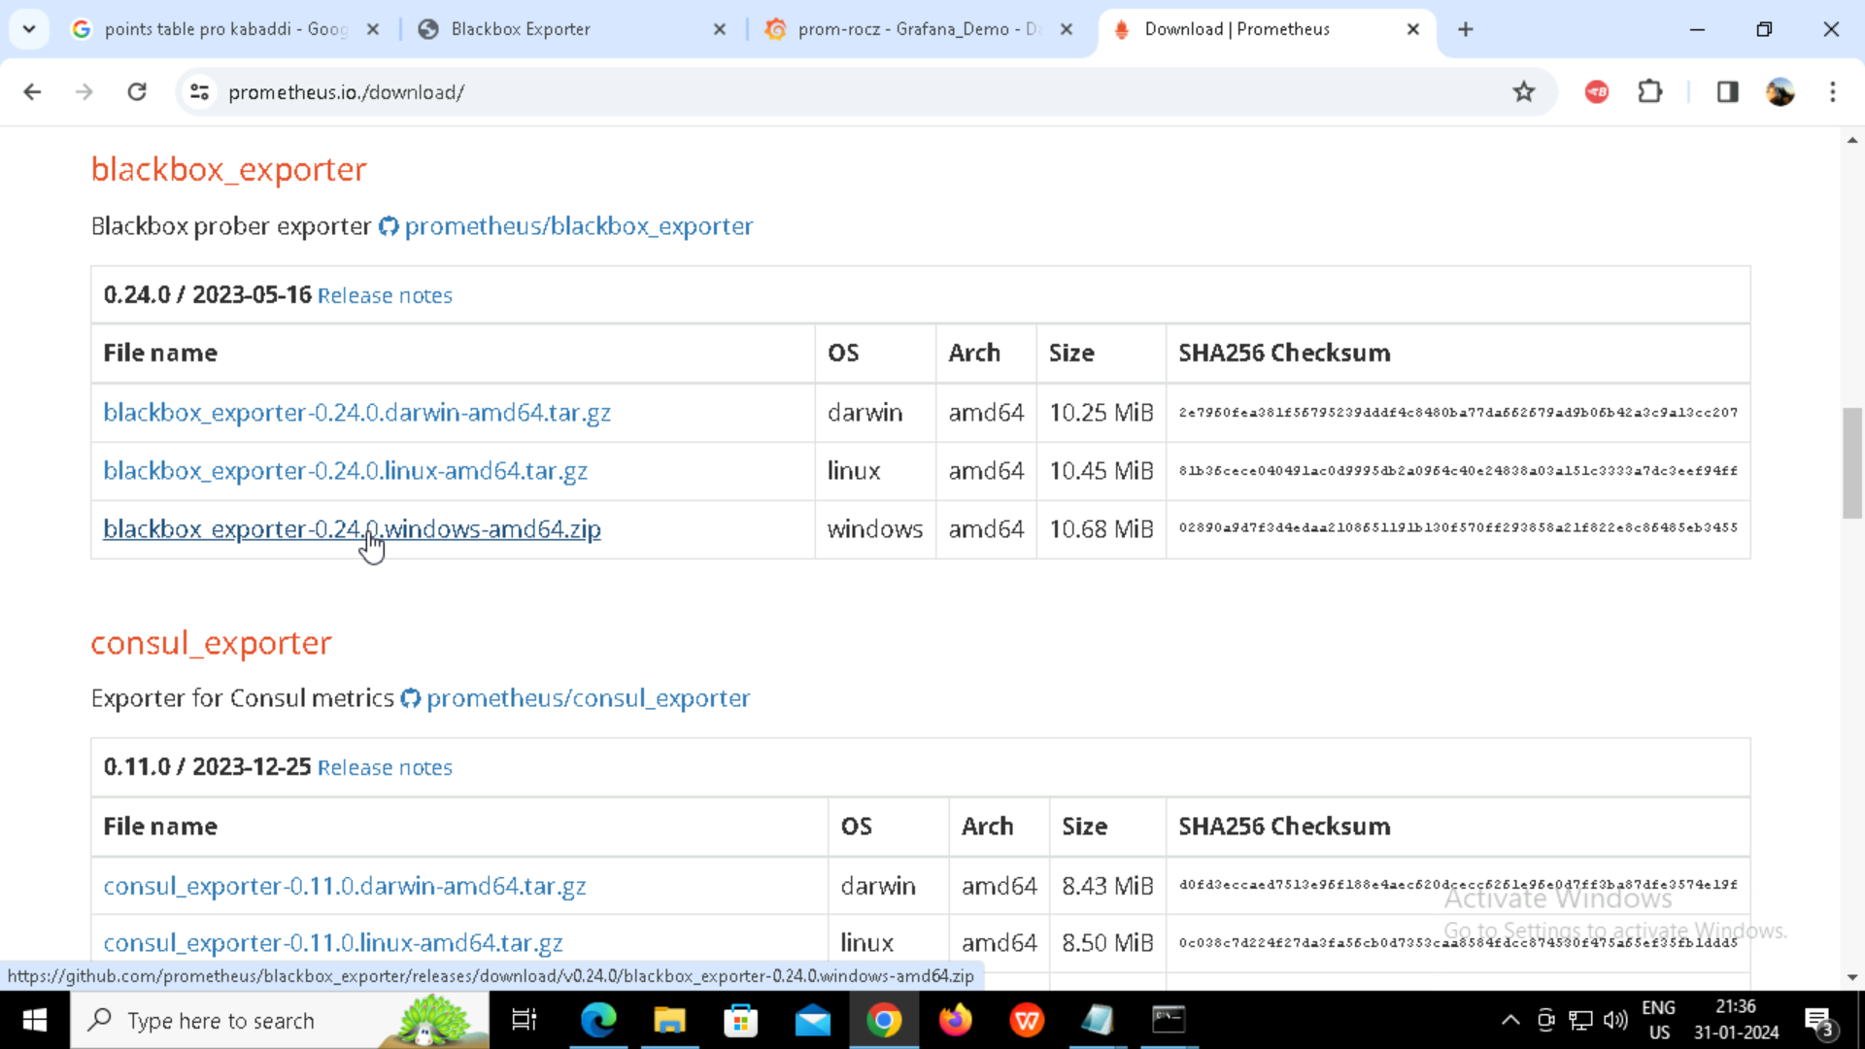

Configuring Prometheus to scrape data from the blackbox_exporter:

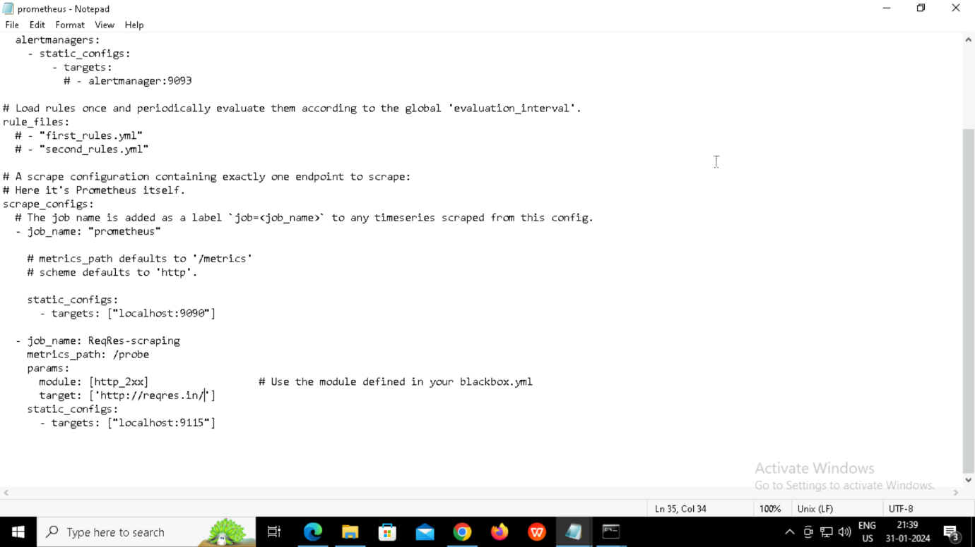

Starting blackbox_exporter:

Starting Prometheus:

Opening Prometheus dashboard and checking targets are being scraped from exporter:

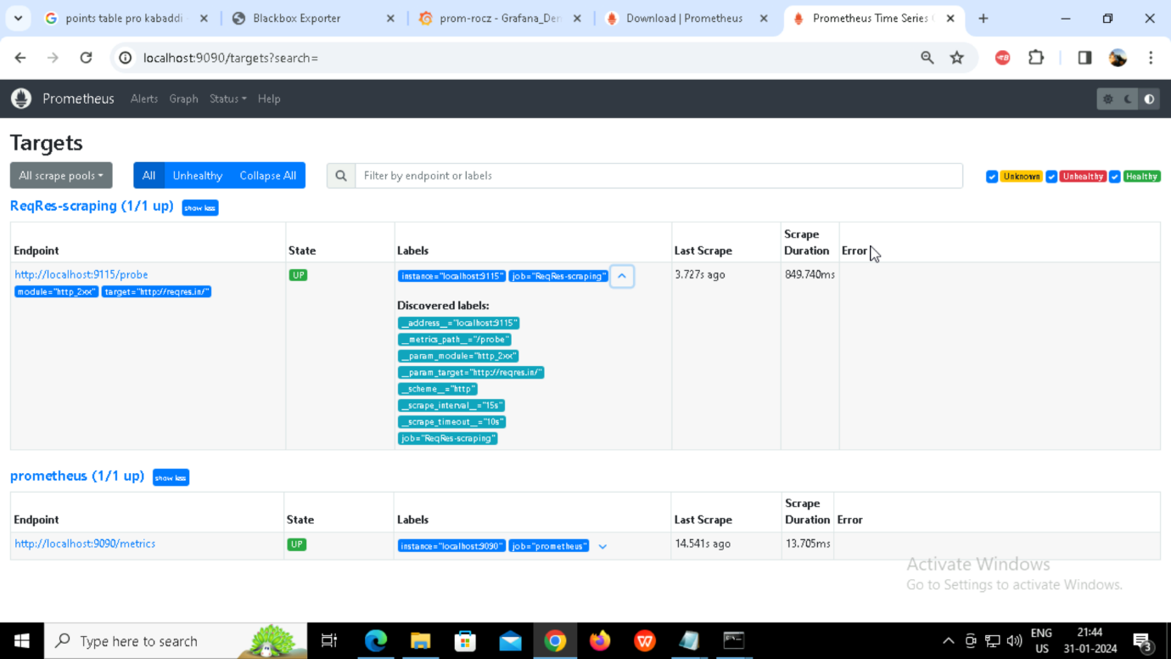

Starting Grafana:

Open Grafana dashboard:

Adding Prometheus data source:

Website Availability (up or down status):

Response time:

Connect:

With annotation adding:

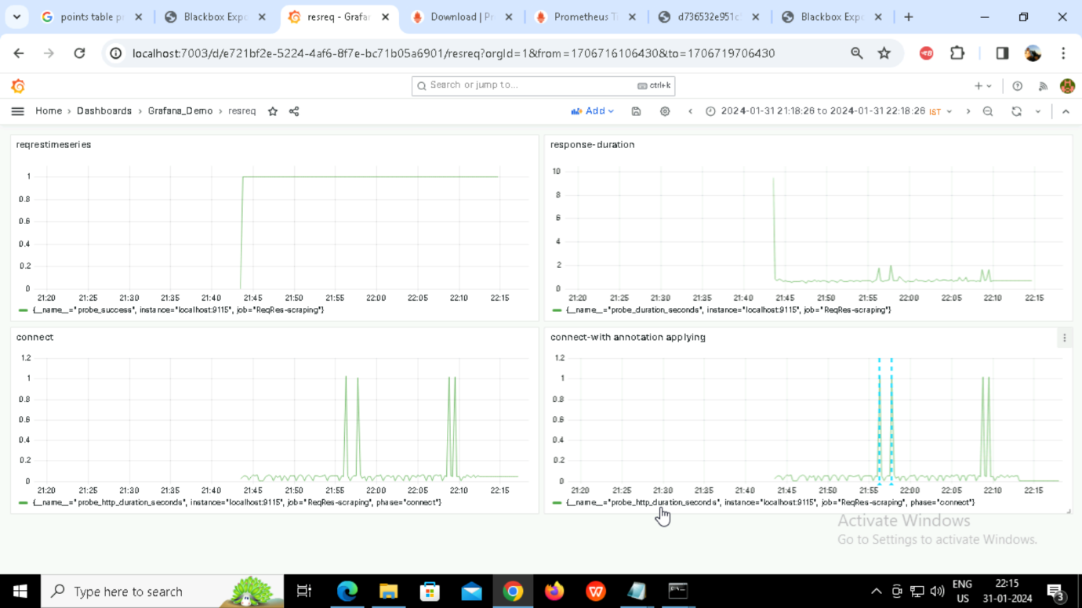

Implement alerting in Grafana for the website’s availability.

